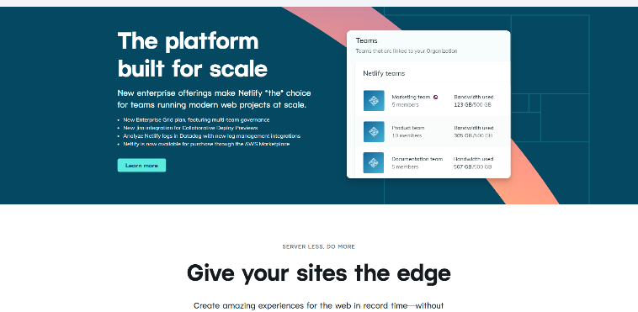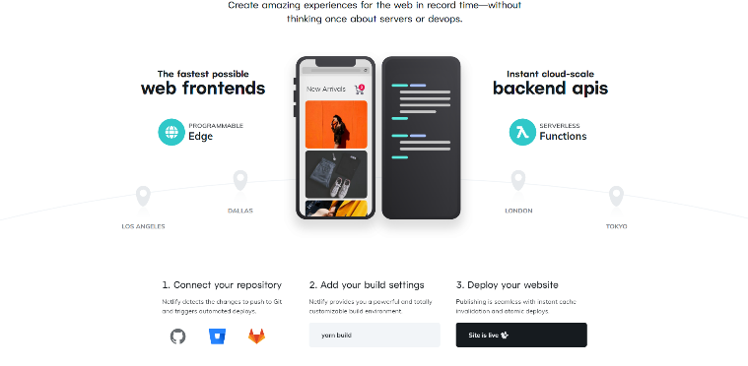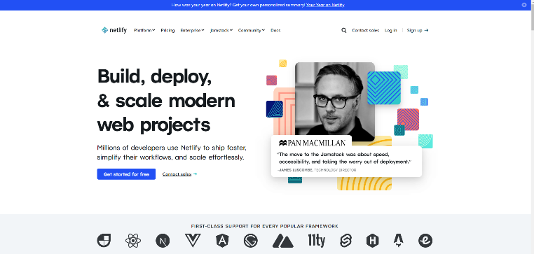

<https://www.netlify.com/>

It offers serverless backend and hosting services for websites and applications. This cloud-computing firm is pillared by AWS lambda functions and integration with lets encrypt.

Netlify has a customer base of many popular companies including Nike, Samsung, Google, Facebook, LiveChat.

Few years age, I took part in this project so I built some post cards, buttons and API by Laravel framework.